Name: PRATIK SUNIL ABHANG
Registration ID: 260640160209
PNR: 260740150018

Question No. 1

Question
Write a C++ program to demonstrate inheritance by creating a Person base class and a Student derived class, accepting and displaying student details including name, age, roll number, and percentage.

Program
#include <iostream>
#include <string>
using namespace std;
class Person
{
protected:
int age;
string name;
public:
Person()
{
age = 0;
name = "";
}
void Accept()
{
cout << "Enter name: ";
cin >> name;
cout << "Enter age: ";
cin >> age;
}
void Display()
{
cout << "\n--- Person Details ---" << endl;
cout << "Name: " << name << endl;
cout << "Age: " << age << endl;
}
};
class Student : public Person
{
private:
int rno;
float percentage;
public:
Student() : Person()
{
rno = 0;
percentage = 0.0;
}
void Accept()
{
Person::Accept();
cout << "Enter Roll Number: ";
cin >> rno;
cout << "Enter Percentage: ";
cin >> percentage;
}
void Display()
{
Person::Display();
cout << "Roll Number: " << rno << endl;
cout << "Percentage: " << percentage << "%" << endl;
}
};
int main()
{
Student s;
cout << "--- Enter Student Details ---" << endl;
s.Accept();
cout << "\n--- Student Details ---" << endl;
s.Display();
return 0;
}

Input & Output
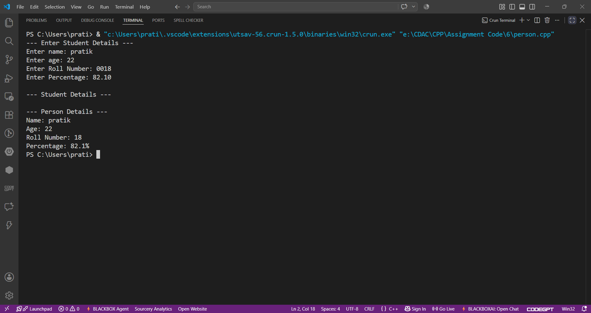

Question No. 2

Question
Write a C++ program to demonstrate abstraction and polymorphism using an abstract Shape class and derived Circle, Rectangle, and Triangle classes to calculate their respective areas.

Program
#include <iostream>
#include <string>
using namespace std;
class Shape
{
protected:
string shapeName;
public:
Shape(string name)
{
shapeName = name;
}
void DisplayShape()
{
cout << "\n--- " << shapeName << " ---" << endl;
}
virtual void Accept() = 0;
virtual void Area() = 0;
};
class Circle : public Shape
{
private:
double radius;
public:
Circle() : Shape("Circle")
{
radius = 0.0;
}
void Accept() override
{
cout << "Enter radius: ";
cin >> radius;
}
void Area() override
{
cout << "Area of Circle: " << (3.14 * radius * radius) << endl;
}
};
class Rectangle : public Shape
{
private:
double length;
double breadth;
public:
Rectangle() : Shape("Rectangle")
{
length = 0.0;
breadth = 0.0;
}
void Accept() override
{
cout << "Enter length: ";
cin >> length;
cout << "Enter breadth: ";
cin >> breadth;
}
void Area() override
{
cout << "Area of Rectangle: " << (length * breadth) << endl;
}
};
class Triangle : public Shape
{
private:
double base;
double height;
public:
Triangle() : Shape("Triangle")
{
base = 0.0;
height = 0.0;
}
void Accept() override
{
cout << "Enter base: ";
cin >> base;
cout << "Enter height: ";
cin >> height;
}
void Area() override
{
cout << "Area of Triangle: " << (0.5 * base * height) << endl;
}
};
int main()
{
Circle c;
Rectangle r;
Triangle t;
Shape *shapes[3];
shapes[0] = &c;
shapes[1] = &r;
shapes[2] = &t;
int ch;
do
{
cout << "\n--- MENU ---" << endl;
cout << "1. Circle" << endl;
cout << "2. Rectangle" << endl;
cout << "3. Triangle" << endl;
cout << "4. Exit" << endl;
cout << "Enter choice: ";
cin >> ch;
switch (ch)
{
case 1:
shapes[0]->Accept();
shapes[0]->DisplayShape();
shapes[0]->Area();
break;
case 2:
shapes[1]->Accept();
shapes[1]->DisplayShape();
shapes[1]->Area();
break;
case 3:
shapes[2]->Accept();
shapes[2]->DisplayShape();
shapes[2]->Area();
break;
case 4:
cout << "Bye" << endl;
break;
default:
cout << "Invalid choice!" << endl;
}
} while (ch != 4);
return 0;
}

Input & Output
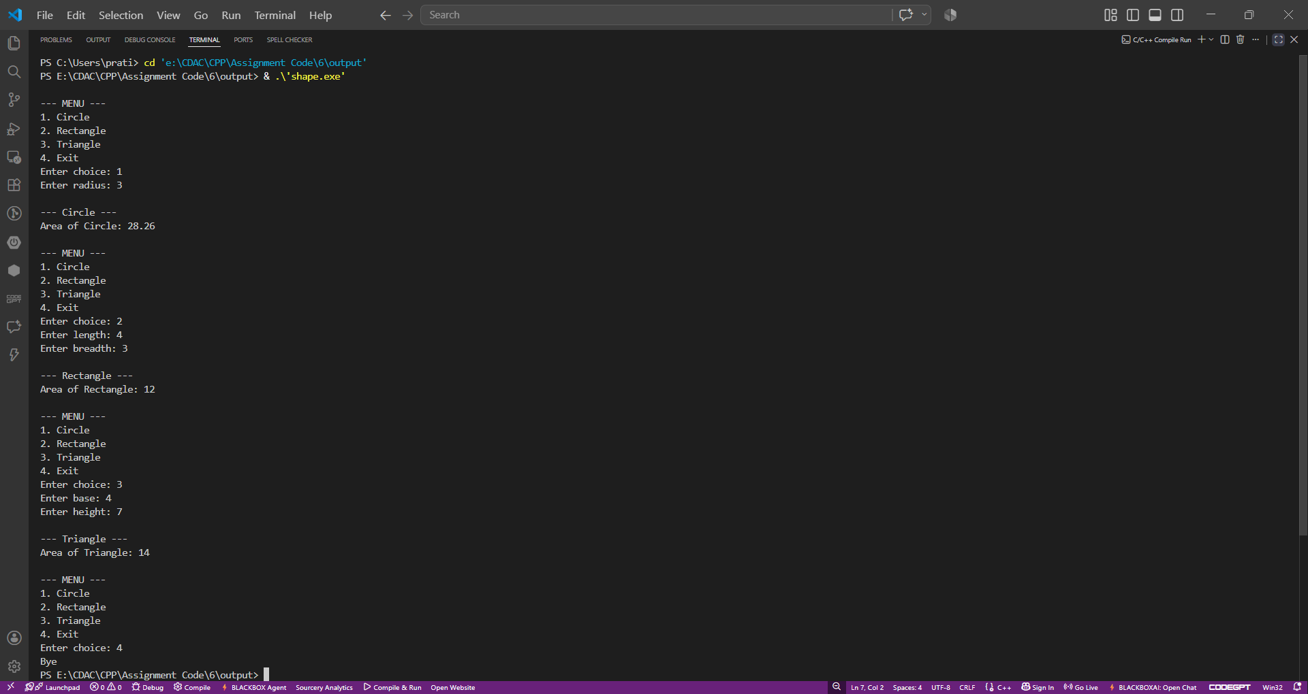

Question No. 3

Question
Write a C++ program to demonstrate inheritance and runtime polymorphism using an Employee base class and Manager, Developer, and SalesEmployee derived classes to accept employee details and calculate salary.

Program
#include <iostream>
#include <string>
using namespace std;
class Employee
{
protected:
int employeeId;
string employeeName;
double basicSalary;
public:
Employee()
{
employeeId = 0;
employeeName = "";
basicSalary = 0.0;
}
virtual void Accept()
{
cout << "Enter Employee ID: ";
cin >> employeeId;
cout << "Enter Employee Name: ";
cin >> employeeName;
cout << "Enter Basic Salary: ";
cin >> basicSalary;
}
virtual void Display()
{
cout << "Employee ID: " << employeeId << endl;
cout << "Employee Name: " << employeeName << endl;
cout << "Basic Salary: " << basicSalary << endl;
}
virtual double calculateSalary() = 0;
};
class Manager : public Employee
{
private:
double allowance;
public:
Manager() : Employee()
{
allowance = 0.0;
}
void Accept() override
{
Employee::Accept();
cout << "Enter Allowance: ";
cin >> allowance;
}
void Display() override
{
cout << "\n--- Manager Details ---" << endl;
Employee::Display();
cout << "Allowance: " << allowance << endl;
}
double calculateSalary() override
{
return basicSalary + allowance;
}
};
class Developer : public Employee
{
private:
double bonus;
public:
Developer() : Employee()
{
bonus = 0.0;
}
void Accept() override
{
Employee::Accept();
cout << "Enter Bonus: ";
cin >> bonus;
}
void Display() override
{
cout << "\n--- Developer Details ---" << endl;
Employee::Display();
cout << "Bonus: " << bonus << endl;
}
double calculateSalary() override
{
return basicSalary + bonus;
}
};
class SalesEmployee : public Employee
{
private:
double salesAmount;
double commissionRate;
public:
SalesEmployee() : Employee()
{
salesAmount = 0.0;
commissionRate = 0.0;
}
void Accept() override
{
Employee::Accept();
cout << "Enter Sales Amount: ";
cin >> salesAmount;
cout << "Enter Commission Rate: ";
cin >> commissionRate;
}
void Display() override
{
cout << "\n--- Sales Employee Details ---" << endl;
Employee::Display();
cout << "Sales Amount: " << salesAmount << endl;
cout << "Commission Rate: " << commissionRate << endl;
}
double calculateSalary() override
{
return basicSalary + (salesAmount * commissionRate);
}
};
int main()
{
int size;
cout << "Enter size of employee array: ";
cin >> size;
if (size <= 0)
{
cout << "Invalid array size!" << endl;
return 1;
}
Employee *employees[size];
for (int i = 0; i < size; i++)
{
employees[i] = nullptr;
}
int count = 0;
int ch;
do
{
cout << "\n--- MENU ---" << endl;
cout << "1. Add Manager" << endl;
cout << "2. Add Developer" << endl;
cout << "3. Add Sales Employee" << endl;
cout << "4. Exit" << endl;
cout << "Enter choice: ";
cin >> ch;
switch (ch)
{
case 1:
if (count >= size)
{
cout << "Array is full!" << endl;
}
else
{
Manager m;
m.Accept();
employees[count] = &m;
employees[count]->Display();
cout << "Calculated Salary: "
<< employees[count]->calculateSalary()
<< endl;
count++;
}
break;
case 2:
if (count >= size)
{
cout << "Array is full!" << endl;
}
else
{
Developer d;
d.Accept();
employees[count] = &d;
employees[count]->Display();
cout << "Calculated Salary: "
<< employees[count]->calculateSalary()
<< endl;
count++;
}
break;
case 3:
if (count >= size)
{
cout << "Array is full!" << endl;
}
else
{
SalesEmployee s;
s.Accept();
employees[count] = &s;
employees[count]->Display();
cout << "Calculated Salary: "
<< employees[count]->calculateSalary()
<< endl;
count++;
}
break;
case 4:
cout << "Bye" << endl;
break;
default:
cout << "Invalid Choice!" << endl;
}
} while (ch != 4);
return 0;
}

Input & Output
